For new task give 9 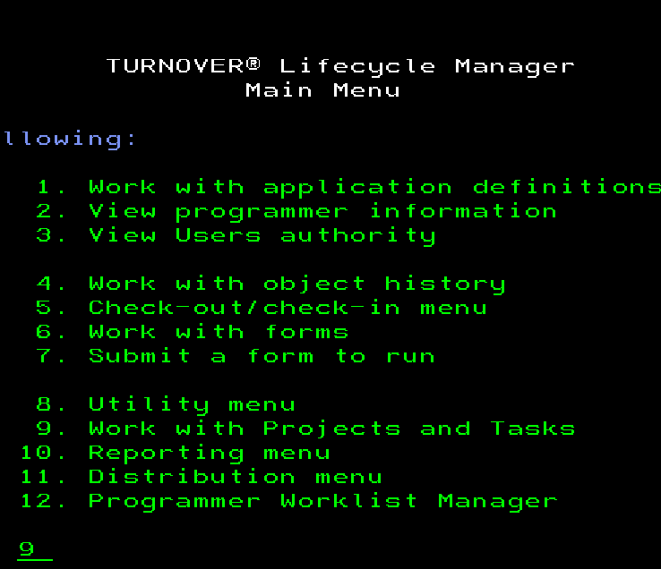

Give 1 on agen 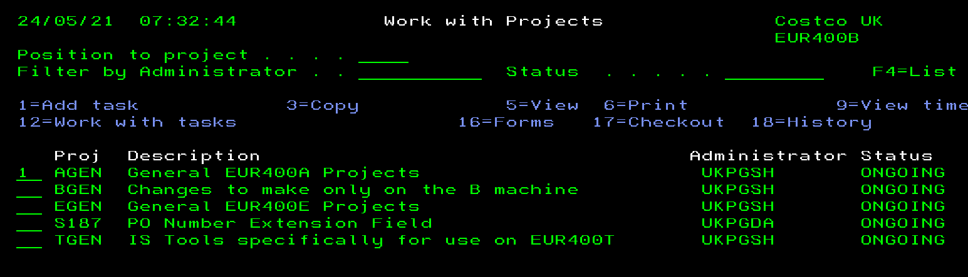

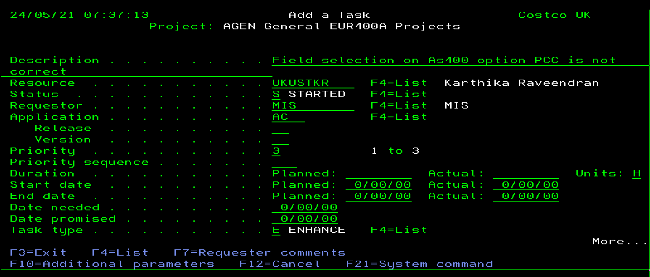

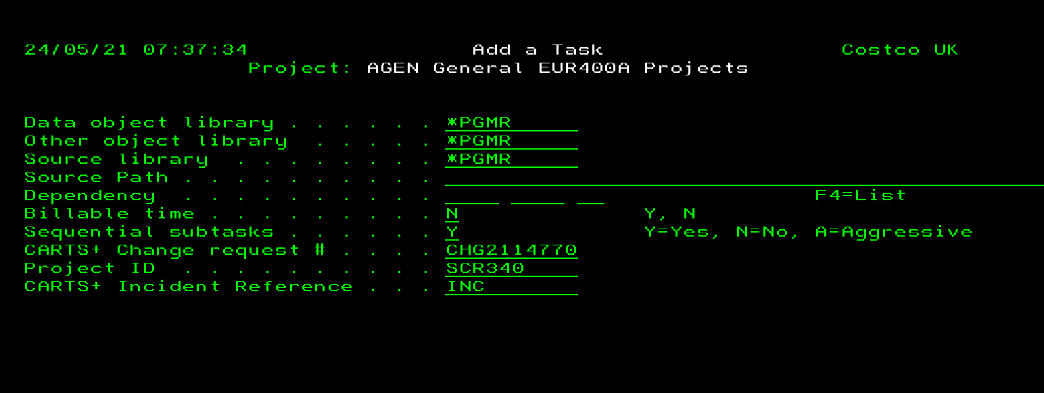

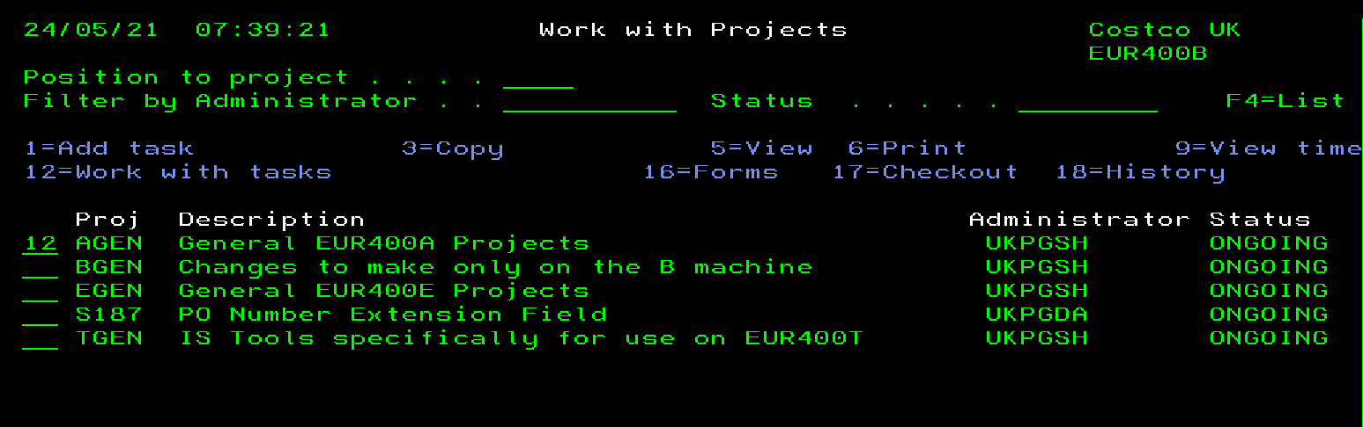

Then after finding your agen give 20

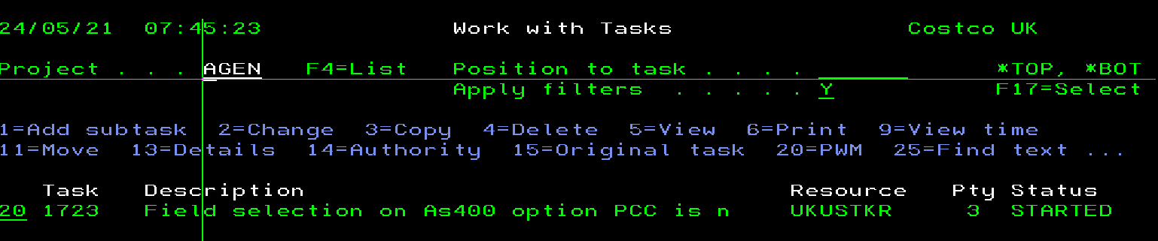

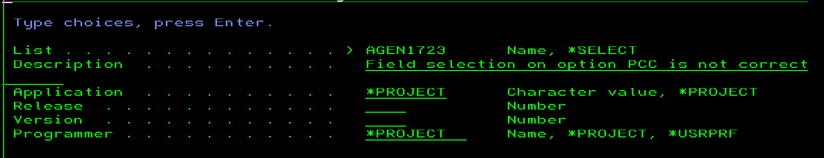

GIVE F6 ANOTHER PAGE APPEARS

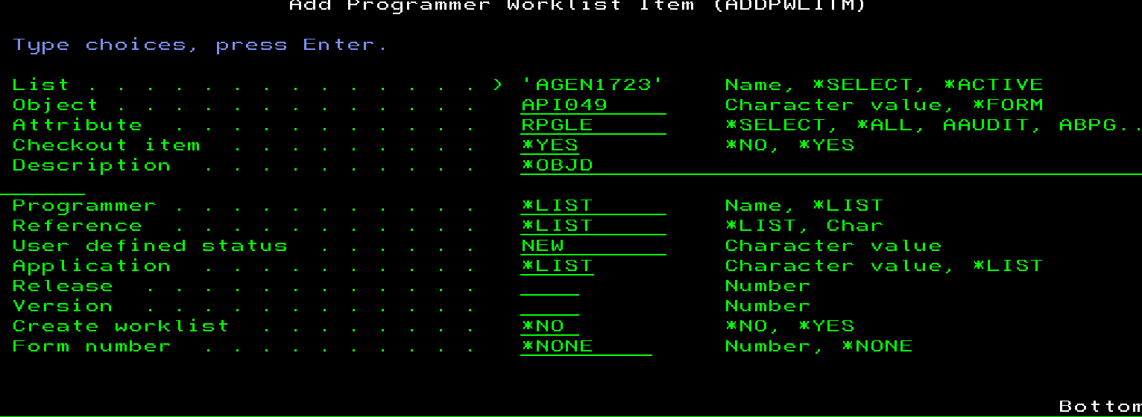

46 on uat lib,then f2

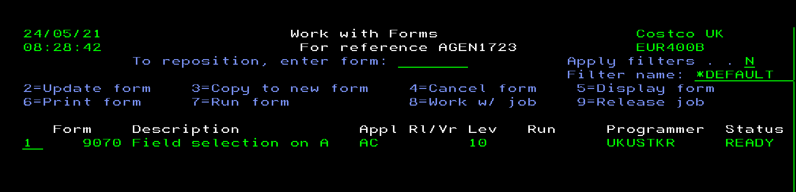

1 FOR ERROR CHECK

F2,7 FOR RUN

TO PRODUCTION

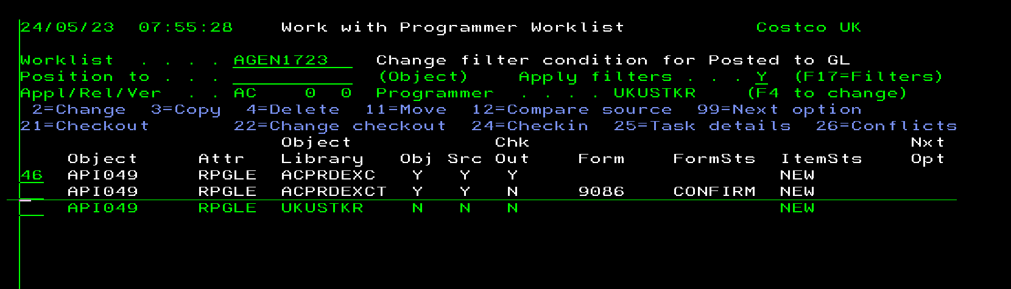

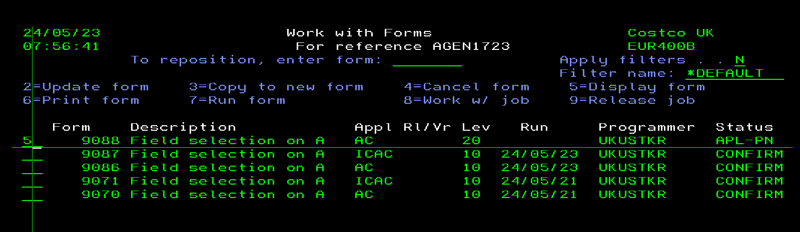

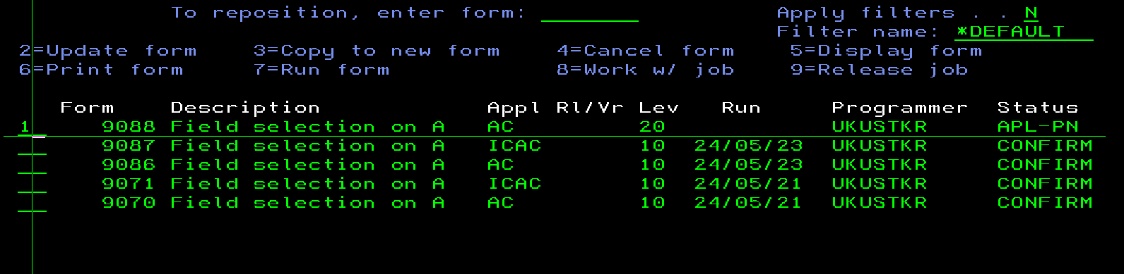

F2- 2update form -10 create parameters -ind

